

MSc Data Science Project
7PAM2002
Department of Physics, Astronomy and Mathematics

Data Science FINAL PROJECT REPORT

Project Title:
Heart Disease Risk Prediction Using
Machine Learning

Student Name and SRN:
Renusree Kakarla and 24087145

Supervisor: Klaas Wiersema
Date Submitted: 20/06/2026
Word Count: 5159
GitHub Link: https://github.com/kakarlarenusree/renu_project_Heart-Disease-Risk-Prediction

DECLARATION STATEMENT

This report is submitted in partial fulfilment of the requirement for the degree of Master of Science in Data Science at the University of Hertfordshire.
I have read the detailed guidance to students on academic integrity, misconduct and plagiarism information at Assessment Offences and Academic Misconduct and understand the University process of dealing with suspected cases of academic misconduct and the possible penalties, which could include failing the project or course.
I certify that the work submitted is my own and that any material derived or quoted from published or unpublished work of other persons has been duly acknowledged. (Ref. UPR AS/C/6.1, section 7 and UPR AS/C/5, section 3.6)
I did not use human participants in my MSc Project.

I hereby give permission for the report to be made available on module websites provided the source is acknowledged.

Student Name printed: Renusree Kakarla

Student Name signature : Renusree Kakarla

Student SRN number: 24087145

UNIVERSITY OF HERTFORDSHIRE
SCHOOL OF PHYSICS, ENGINEERING AND COMPUTER SCIENCE

Table of contents:

 | Title | Page No.
 | ABSTRACT | 5
1 | INTRODUCTION | 6
1.1 | Background | 6
1.2 | Motivation | 6
1.3 | Research Question | 7
1.4 | Objectives | 7
2. | LITERATURE REVIEW | 8
2.1 | Overview of Existing Studies | 8
2.2 | Comparison of Literature | 9
3. | DATASET | 11
3.1 | Dataset Overview | 11
3.2 | Feature Description | 11
3.3 | Missing Values | 12
4. | ETHICAL CONSIDERATIONS | 13
5. | METHODOLOGY | 14
5.1 | Data Preprocessing | 14
 | 5.1.1 Target Variable Binarisation | 14
 | 5.1.2 Handling Missing Values | 14
 | 5.1.3 Train-Test Split | 15
 | 5.1.4 SMOTE -Class Imbalance Handling | 15
 | 5.1.5 Feature Scaling | 15
5.2 | Exploratory Data Analysis (EDA) | 15
 | 5.2.1 Univariate Analysis | 15
 | 5.2.2 Bivariate Analysis | 16
 | 5.2.3 Categorical Feature Analysis | 17
 | 5.2.4 Correlation Analysis | 17
 | 5.2.5 Outlier Analysis | 18
5.3 | Model Selection | 19
 | 5.3.1 Logistic Regression | 19
 | 5.3.2 Random Forest | 19
 | 5.3.3 XGBoost | 19
5.4 | Model Evaluation Metrics | 20
5.5 | Hyperparameter Tuning | 20
5.6 | Explainable AI using SHAP | 21
6. | RESULTS | 23
6.1 | Comprehensive Model Performance Comparison | 23
6.2 | ROC Curve Analysis | 24
6.3 | Confusion Matrix Analysis | 25
6.4 | SHAP Explainability Results | 25
6.5 | Key Findings | 26
7. | ANALYSIS AND DISCUSSION | 27
7.1 | Interpretation of Results | 27
7.2 | Effect of SMOTE | 27
7.3 | Model Comparison | 27
7.4 | Clinical Relevance | 27
7.5 | Explainability Discussion | 27
7.6 | Limitations | 28
8. | CONCLUSION | 29
9. | FUTURE WORK | 30
 | REFERENCES | 31
 | APPENDIX | 32
ABSTRACT

Heart disease remains one of the leading causes of mortality worldwide, creating a need for accurate and interpretable predictive models that can support clinical decision-making. This study investigates the effectiveness of three machine learning classification models—Logistic Regression, Random Forest, and XGBoost—for heart disease risk prediction using the Cleveland Heart Disease dataset from the UCI Machine Learning Repository. The dataset contains 303 patient records and 13 clinical attributes associated with cardiovascular health.
Data preprocessing involved target variable binarisation, removal of six records containing missing values, stratified train-test splitting, and Synthetic Minority Over-sampling Technique (SMOTE) to address class imbalance within the training data. Hyperparameter optimisation was performed using GridSearchCV with five-fold cross-validation. Model performance was evaluated using accuracy, precision, recall, F1-score, and ROC-AUC.
A three-stage evaluation framework was implemented, comparing model performance before SMOTE, after SMOTE, and after SMOTE combined with hyperparameter tuning. Results showed that all models achieved strong predictive performance, with Random Forest obtaining the highest ROC-AUC (0.951), while XGBoost achieved the most consistent overall balance across accuracy, precision, recall, and F1-score. Logistic Regression also demonstrated competitive performance despite its simpler linear structure.
To improve model transparency, SHAP (SHapley Additive exPlanations) was applied to all tuned models. The explainability analysis consistently identified thal, ca, cp, oldpeak, and thalach as the most influential predictors of heart disease. Strong agreement across the three model architectures increased confidence in the clinical relevance of these features.
The findings demonstrate that machine learning models can provide reliable heart disease risk prediction while maintaining interpretability through explainable AI techniques. This combination of predictive performance and transparency supports the potential use of such approaches in future clinical decision-support systems.

1.INTRODUCTION
1.1 Background
Heart disease is one of the leading causes of mortality worldwide, responsible for approximately 17.9 million deaths each year — around 32% of all global deaths. In the United Kingdom, cardiovascular conditions account for roughly 25% of annual deaths, imposing a significant burden on healthcare systems. These statistics highlight the critical need for early detection and prevention strategies.
Recent advances in data science and machine learning offer quantitative frameworks for analysing structured clinical data and predicting disease risk. Machine learning models can evaluate multiple clinical variables simultaneously, identify nonlinear relationships between predictors, and produce probabilistic risk scores — capabilities that complement, and in some respects exceed, traditional statistical methods. Equally important is interpretability: in clinical settings, clinicians must be able to understand and trust model predictions before acting on them. Explainable AI techniques such as SHAP bridge the gap between predictive performance and clinical transparency.
This study applies three machine learning classifiers to the Cleveland Heart Disease dataset (UCI Machine Learning Repository), using SMOTE for class balancing, GridSearchCV for hyperparameter optimisation, and SHAP for post-hoc explainability. The comparative SHAP analysis across all three models is a central contribution of this work.
Despite progress in machine learning-based heart disease prediction, many studies focus primarily on predictive performance with limited analysis of interpretability — yet in healthcare, accuracy alone is insufficient; clinicians must understand the factors driving a prediction to trust and act on it. Relatively few studies systematically compare explainability results across multiple architectures using a common dataset, a gap this study addresses through SHAP-based explainability analysis across Logistic Regression, Random Forest and XGBoost.

1.2 Motivation
The motivation for this project stems from the growing demand for automated, transparent, data-driven healthcare tools that can assist clinicians in risk stratification. Manual clinical assessment is time-intensive, and subtle patterns in multivariate patient data may be missed without computational support. Machine learning models trained on validated clinical datasets offer a scalable and reproducible solution. This project explores whether such models can reliably predict heart disease risk and whether their predictions can be made sufficiently transparent for clinical trust through explainable AI.

1.3 Research Question:
Can machine learning classification models — specifically Logistic Regression, Random Forest, and XGBoost — accurately predict heart disease risk from structured clinical data in the UCI Cleveland Heart Disease dataset, and can SHAP-based explainability identify the most clinically relevant predictors consistently across all three model architectures?
1.4 Objectives:
- The objectives of this project are outlined as follows:
- Conduct thorough exploratory data analysis to understand feature distributions, class balance, correlations, and potential multicollinearity.
- Preprocess the dataset by handling missing values, binarising the target variable, and creating a stratified train-test split.
- Apply SMOTE to the training set only to address class imbalance, and compare model performance before and after SMOTE.
- Implement and compare Logistic Regression, Random Forest, and XGBoost classifiers across three stages: no SMOTE, SMOTE before tuning, and SMOTE with GridSearchCV tuning.
- Evaluate model performance using accuracy, precision, recall, F1-score, and ROC-AUC, with emphasis on recall and ROC-AUC in the clinical context.
- Apply SHAP analysis to all three tuned models and conduct a comparative cross-model explainability analysis to identify the most influential clinical features.

2. LITERATURE REVIEW
2.1 Overview of Existing Studies
Machine learning has become an important tool for heart disease prediction because it can analyse multiple clinical variables simultaneously and identify complex relationships that may not be apparent using traditional statistical approaches. The Cleveland Heart Disease dataset remains one of the most widely used benchmark datasets in this area due to its clinical relevance and public availability (Detrano et al., 1989).
Among traditional machine learning methods, Logistic Regression is frequently used as a baseline classifier because of its simplicity and interpretability. While it provides transparent predictions and performs well on structured medical datasets, its ability to model nonlinear relationships is limited. As a result, more recent studies have increasingly focused on ensemble learning methods such as Random Forest and XGBoost, which generally achieve stronger predictive performance by combining the outputs of multiple decision trees.
Research consistently demonstrates the advantages of ensemble models for heart disease prediction. Soni et al. (2011) conducted an early survey of predictive data mining techniques for medical diagnosis, reporting that tree-based classifiers could effectively identify cardiovascular risk patterns in clinical datasets. Similarly, Yang and Guan (2022) showed that integrating XGBoost with SMOTE and feature selection via information gain achieved a prediction accuracy of 93.44% on a heart disease dataset, highlighting the importance of appropriate preprocessing alongside model selection. These findings suggest that both algorithm choice and data preparation significantly influence classification outcomes.
Alongside improvements in predictive accuracy, there has been increasing interest in explainable artificial intelligence (XAI). In healthcare applications, model transparency is essential because clinicians must understand the factors influencing predictions before incorporating them into decision-making processes. SHAP was introduced by Lundberg and Lee (2017) as a unified framework for interpreting model predictions, grounding feature importance in Shapley values from cooperative game theory. It provides both global feature importance rankings and local explanations for individual predictions, and has since become one of the most widely adopted explainability techniques in machine learning. Lundberg et al. (2020) subsequently extended this approach specifically for tree-based models, demonstrating exact and computationally efficient SHAP value calculation for ensembles such as Random Forest and XGBoost. Recent studies applying SHAP to cardiovascular datasets have consistently identified variables such as chest pain type, maximum heart rate, ST depression, and thalassemia status as important indicators of heart disease risk.
Although recent studies have reported strong predictive performance, several limitations remain. Many investigations focus primarily on maximising accuracy and provide limited discussion of model interpretability. Others evaluate only a single machine learning algorithm, making it difficult to determine whether identified predictors remain consistent across different modelling approaches. Furthermore, preprocessing techniques such as SMOTE, hyperparameter optimisation, and explainability methods are often investigated separately rather than within a unified framework.
This study addresses these limitations by comparing Logistic Regression, Random Forest, and XGBoost using the Cleveland Heart Disease dataset. The models are evaluated before and after applying SMOTE and hyperparameter tuning, while SHAP is used to compare feature importance across all three algorithms. This approach enables both predictive performance and interpretability to be assessed simultaneously, providing a more comprehensive evaluation of machine learning techniques for heart disease prediction.
2.2 Comparison of Literature

Study | Model | Dataset | Accuracy/AUC | Key Method
Detrano et al. (1989) | Bayesian discriminant function | Cleveland (303 patients) | 68% correctly classified | Original clinical dataset paper; figure from UCI repository documentation
Soni et al. (2011) | Decision Trees, Naive Bayes, SVM | Cleveland UCI | Varies by classifier | Survey of predictive data mining for medical diagnosis; no single reported accuracy applicable across all classifiers
Chen & Guestrin (2016) | XGBoost | Multiple benchmarks | State of the art on structured data | Gradient boosting framework
Lundberg & Lee (2017) | SHAP (model-agnostic) | Multiple domains | N/A (interpretability method) | Original SHAP paper; unified Shapley-value framework for model interpretability
Yang & Guan (2022) | XGBoost + SMOTE + information gain feature selection | UCI Heart Disease Dataset | 93.44% accuracy | Class imbalance handling with SMOTE-ENN; feature selection improves XGBoost performance
Nahar et al. (2026) | Stacked ensemble (SVM, KNN, NB, DT) + LR meta-learner + SHAP | Five combined public HD datasetsUCI | 93.69% accuracy, AUC 0.947 | SMOTE + dimensionality reduction + explainability; trained on combined datasets, not Cleveland alone
Raman et al. (2026) | LR, RF, XGBoost, Neural Network + SHAP | Cleveland + Framingham | Best Cleveland AUC ~0.92 (RF); Framingham LR AUROC 0.72 | Leakage-controlled XAI pipeline; results differ by dataset; Cleveland and Framingham reported separately
Table 1: Comparison of existing literature on heart disease prediction

3.DATASET
3.1 Dataset Overview
The dataset used in this project is the Cleveland Heart Disease dataset, which is widely used for supervised machine learning tasks involving classification of heart disease presence. The dataset was originally collected by the Cleveland Clinic Foundation in 1988 for medical research purposes. It is publicly available through the UCI Machine Learning Repository and the Kaggle Machine Learning Repository.
The original dataset contains 76 recorded attributes from 303 patients; as in most analytical studies, a reduced set of 14 clinically significant features plus the target variable was used here, covering key cardiovascular indicators such as demographic, ECG and exercise-related measures (full details in Table 2).
The target variable reflects the presence of heart disease. In the original form, it is defined as a multi-class label ranging from 0 to 4, where 0 denotes absence of disease and values from 1 to 4 represent increasing levels of severity. For the purpose of this study and most predictive modelling tasks, this is reformulated into a binary classification problem in which:
- 0 = No heart disease
- 1 = Presence of heart disease
The dataset exhibits class imbalance, with a higher number of non-disease cases compared to disease cases. This makes it suitable for evaluating model robustness and performance using multiple evaluation metrics.
3.2 Feature Description
Table 2 below provides a complete description of all 13 input features used in this study.
Order | Feature | Description | Value Range
1 | Age | Age of patient | 29-77
2 | Sex | Gender | 0=female,1=male
3 | Cp | Chest pain type | 0-3
4 | Trestbps | Resting blood pressure | 94-200 mmHg
5 | Chol | Serum cholesterol | 126-564 mg/dL
6 | Fbs | Fasting blood sugar | 0-1
7 | Restecg | ECG results | 0-2
8 | Thalach | Maximum heart rate achieved | 71-202
9 | Exang | Exercise-induced angina | 0-1
10 | Oldpeak | ST depression | 0-6.2
11 | Slope | ST segment slope | 0-2
12 | Ca | Number of major vessels | 0-3
13 | Thal | Thalassemia condition | 0-2
14 | Target | Heart disease diagnosis | 0-1
Table 2: Description of features in the Cleveland Heart Disease dataset
3.3 Missing Values
The dataset contains six missing values in total: four in the ca feature (number of major vessels) and two in the thal feature (thalassemia condition). These missing entries are represented as '?' in the raw data file and were converted to NaN during loading.
Given that only six observations (approximately 2% of the dataset) contain missing values, complete-case deletion (dropping the six affected rows) was used rather than imputation. Imputation could introduce bias into categorical features like thal, which takes only three specific values (3, 6, 7) and cannot be meaningfully replaced by a mean. After removal, 297 complete records were retained for analysis.
It is important to note that the values present in all other features were inspected for clinical plausibility. Cholesterol values ranged from 126 to 564 mg/dL, which, while the upper bound is clinically extreme, is within the range of severe hypercholesterolaemia and was retained as a valid outlier rather than an error. Resting blood pressure (94–200 mmHg) and maximum heart rate (71–202) also fell within clinically plausible ranges, and no values were identified as impossible or clearly erroneous.
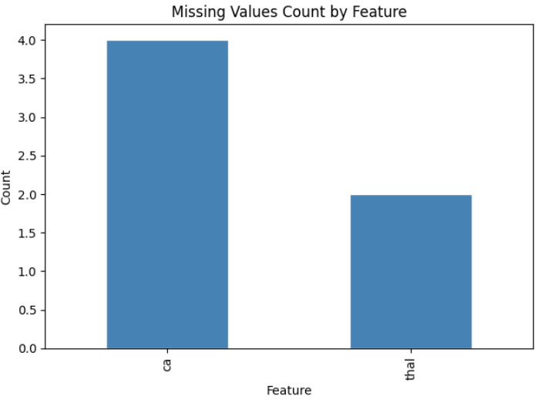
Figure 1: Missing Values Count for Features in the Dataset

4. ETHICAL CONSIDERATIONS
The Cleveland Heart Disease dataset is fully anonymised; patient names and social security numbers were removed prior to public release and replaced with dummy values (Detrano et al., 1989). The dataset is publicly available through the UCI Machine Learning Repository under a Creative Commons Attribution 4.0 International licence (CC BY 4.0), which permits academic use with attribution.
No human participants were directly involved in this study. All analyses were performed on pre-existing, de-identified data.
From a practical standpoint, any machine learning model intended for deployment in a clinical setting must be subjected to rigorous independent validation before clinical use. The models developed in this study are intended for research purposes only and should not be used as substitutes for professional medical diagnosis. Risks include demographic bias — the Cleveland dataset was collected at a single institution in the United States and may not generalise to other populations, particularly those with different age distributions, ethnicities, or clinical practices.
The use of explainable AI (SHAP) partially addresses ethical concerns around transparency, as it allows clinicians and patients to understand which features drove a given prediction, supporting informed consent and professional oversight.

5.METHODOLOGY
5.1 Data Preprocessing
Data preprocessing was performed in the following order, consistent with the implementation in the Jupyter notebook:
(1) Loading the raw data with missing values marked as NaN.
(2) Binarising the target variable.
(3) Dropping the six rows with missing values.
(4) Performing a stratified train-test split.
(5) Applying SMOTE to the training set.
(6) Scaling features for Logistic Regression.
5.1.1 Target Variable Binarisation
The target variable was transformed from its original ordinal scale (0–4) to a binary label: 0 (no disease) and 1 (presence of disease). All values greater than zero were mapped to 1, consistent with Cleveland dataset literature and implemented as: df['target'] = df['target'].apply(lambda x: 1 if x > 0 else 0).
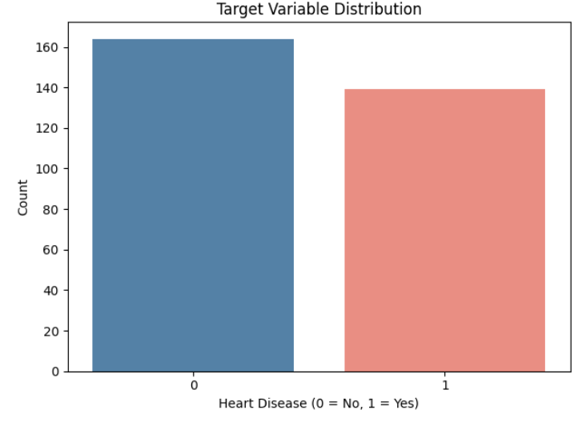
Figure 2: Target variable distribution
5.1.2 Handling Missing Values
Six rows containing missing values in ca and thal were removed after target binarisation. These features are categorical, making mean imputation methodologically inappropriate. Removal was performed prior to train-test splitting to prevent any information from missing-value rows leaking into the test set.
5.1.3 Train-Test Split
The cleaned dataset (297 records) was divided into training (80%, 237 records) and testing (20%, 60 records) sets using stratified sampling to preserve the class distribution in both subsets. Stratification ensures that the proportion of positive and negative cases is consistent across the split, which is particularly important given the moderate class imbalance.
5.1.4 SMOTE — Class Imbalance Handling
SMOTE (Synthetic Minority Over-sampling Technique) was applied to the training set only, after the train-test split, to prevent synthetic samples from appearing in the test set. SMOTE works by creating new minority-class samples by interpolating between existing minority observations and their k-nearest neighbours. The class distribution was examined before and after SMOTE to quantify the effect of resampling on training set balance.
Three model stages were subsequently compared: (1) No SMOTE — models trained on the raw imbalanced training set; (2) SMOTE before tuning — models trained on SMOTE-balanced data with default hyperparameters; (3) SMOTE + GridSearchCV tuning — the final tuned models.
5.1.5 Feature Scaling
Continuous numerical features were standardised using StandardScaler (zero mean, unit variance) for Logistic Regression, which is sensitive to feature magnitude because coefficients are estimated by gradient-based optimisation. Separate scalers were fitted: one on the SMOTE-balanced training data (X_train_sm_scaled) for the tuned Logistic Regression, and a consistent scaler applied to the test set (X_test_scaled). Random Forest and XGBoost are tree-based and invariant to monotonic feature transformations; scaling was not required for these models.
5.2 Exploratory Data Analysis (EDA)
Exploratory Data Analysis (EDA) was conducted to understand the structure of the dataset, identify patterns, detect anomalies, and guide preprocessing and model selection. The analysis included univariate analysis, bivariate analysis, categorical feature analysis, correlation analysis, and outlier detection.
5.2.1 Univariate Analysis
Univariate analysis was performed to examine the distribution of individual features. Histograms with KDE overlays were generated for numerical variables such as age, cholesterol, resting blood pressure, maximum heart rate, and ST depression.
Age was approximately normally distributed, cholesterol showed right-skewness, maximum heart rate displayed a wide spread, and oldpeak values were concentrated at lower levels, with severe ST depression occurring less frequently. These distributions indicated that feature scaling would be necessary for numerical variables.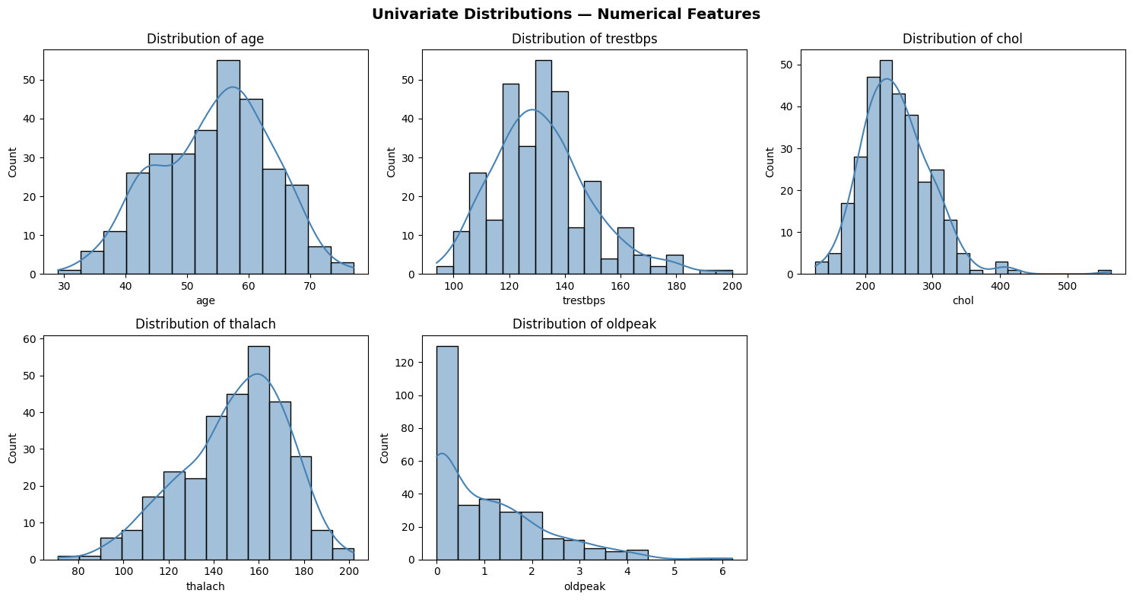
Figure 3: Univariate analysis over numerical features
5.2.2 Bivariate Analysis
Boxplots compared age, resting blood pressure, cholesterol, maximum heart rate (thalach), and oldpeak between patients with and without heart disease. Disease-positive patients generally had higher age and oldpeak values and lower thalach, while resting blood pressure and cholesterol overlapped considerably between groups — making thalach and oldpeak the clearest candidate predictors among the numerical features.
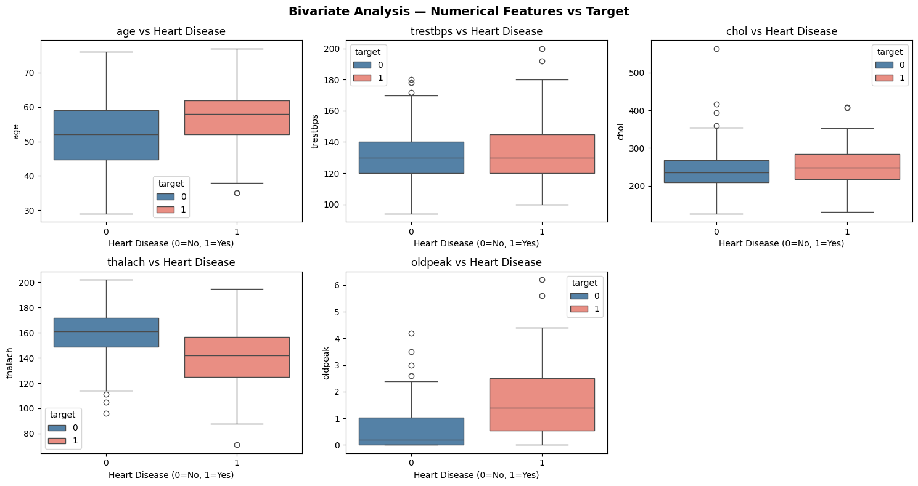
Figure 4: Bivariate analysis over numerical features
5.2.3 Categorical Feature Analysis
Count plots for sex, chest pain type (cp), exercise-induced angina (exang), slope and thal showed that cp and exang were strongly associated with heart disease, with further differences in slope and thal between classes — indicating these categorical features were worth retaining for modelling.
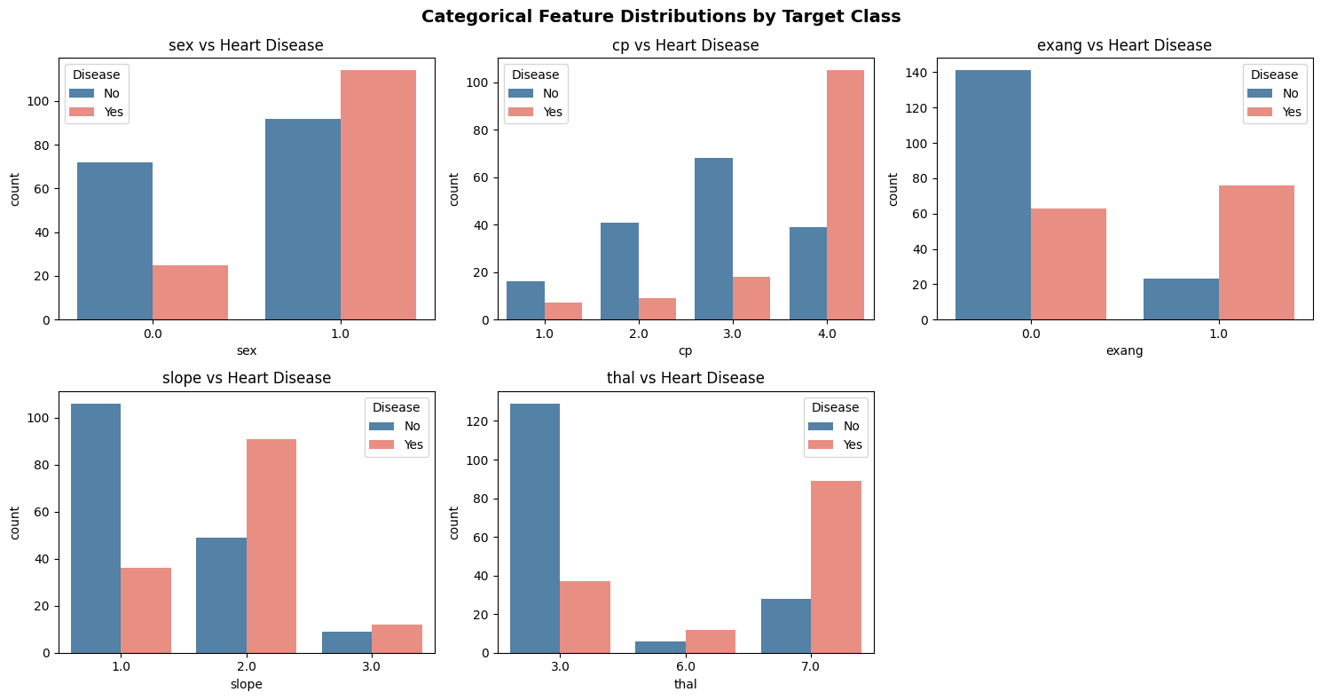
Figure 5: Categorical Feature analysis by Target class

5.2.4 Correlation Analysis
A Pearson correlation heatmap showed thal (-0.53), ca (0.46), oldpeak (0.42), exang (0.42) and cp (0.41) had the strongest associations with heart disease, while thalach showed a moderate negative correlation (-0.42) — lower heart rates being associated with higher disease likelihood. Most feature pairs exhibited low to moderate correlations, indicating limited multicollinearity, so all features were retained for model training.
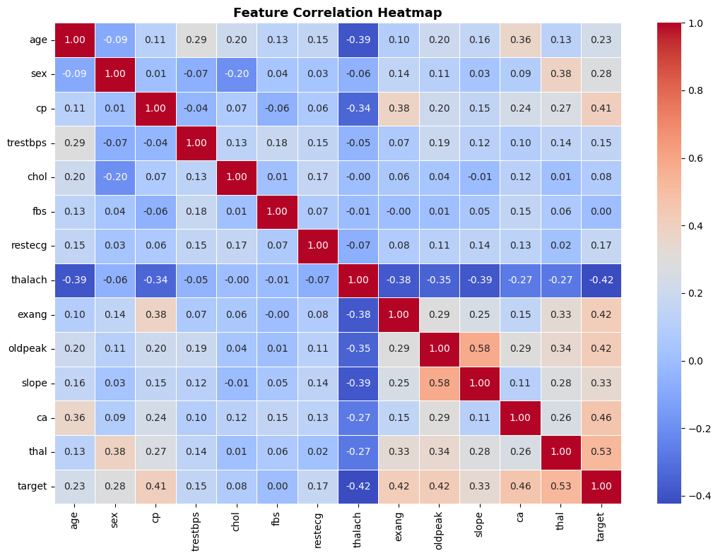
Figure 6: Correlation analysis heatmap for numerical variables
5.2.5 Outlier Analysis
Box plots were used to identify potential outliers in the numerical features. Outliers were observed mainly in cholesterol (chol), resting blood pressure (trestbps), and oldpeak. However, these values were retained because they represent realistic clinical measurements and may contain important information for predicting heart disease. No outlier removal was performed during data preprocessing.
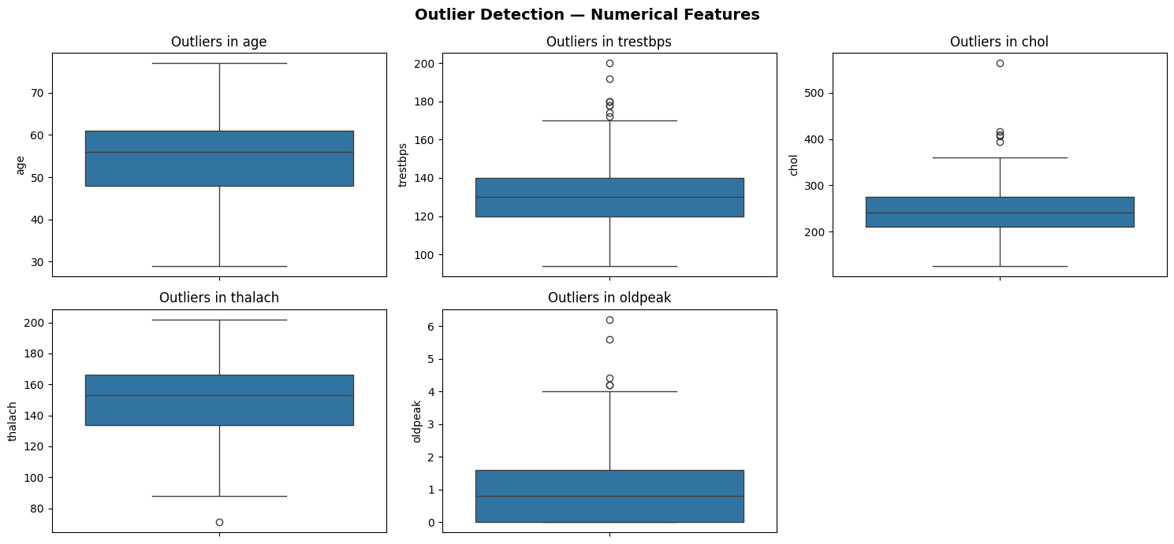
Figure 7: Outlier analysis for numerical variable
5.3 Model Selection
Three models were selected to represent different learning paradigms: Logistic Regression (linear baseline), Random Forest (ensemble bagging), and XGBoost (ensemble boosting). This selection enables systematic comparison across model complexity while remaining interpretable through SHAP.
5.3.1 Logistic Regression
Logistic Regression models the probability of a binary outcome by applying the sigmoid function to a linear combination of input features. Each coefficient represents the change in log-odds of disease for a one-unit increase in that feature. It serves as the interpretable baseline: coefficients are directly readable as log-odds ratios, and LinearExplainer enables exact SHAP computation. Key hyperparameter: max_iter=1000 to ensure convergence.
5.3.2 Random Forest
Random Forest constructs multiple independent decision trees on bootstrap samples of the training data. At each node, only a random subset of features is considered. This double injection of randomness — in data sampling and feature selection — decorrelates trees, reducing variance compared to a single decision tree without significantly increasing bias. It handles nonlinear relationships without feature scaling and provides built-in feature importances that complement SHAP analysis. Key hyperparameters tuned: n_estimators, max_depth, min_samples_split, max_features, min_samples_leaf.
5.3.3 XGBoost
XGBoost (Extreme Gradient Boosting) builds trees sequentially, with each new tree correcting the residual errors of the current ensemble. It minimises a regularised objective function combining log-loss and a regularisation term penalising model complexity. Shrinkage (learning rate) and subsampling further control overfitting. Unlike Random Forest, XGBoost focuses successive trees on the hardest-to-predict samples, making it particularly effective on complex or imbalanced datasets. Key hyperparameters tuned: n_estimators, max_depth, learning_rate, subsample.
5.4 Model Evaluation Metrics
Five classification metrics were used to evaluate model performance comprehensively. Given the clinical context, recall and ROC-AUC were prioritised, as false negatives (patients with heart disease classified as healthy) are the most dangerous error type.
- Accuracy – Overall correctness.
$$Accuracy=\frac{TP+TN}{TP+TN+FP+FN}$$
- Precision – Predicted Positives, how many are truly positive.
$$Precision=\frac{TP}{TP+FP}$$

- Recall (Sensitivity) – Actual positives, how many are correctly identified. Most clinically critical metric in this context.
$$Recall=\frac{TP}{TP+FN}$$
- F1-Score – Harmonic mean balancing precision and recall.
$$F1=2⋅\frac{Precision⋅Recall}{Precision+Recall}$$
- ROC-AUC – Threshold-independent measure of model discrimination; used as the primary optimisation metric in GridSearchCV.
To provide a clearer understanding of classification performance, confusion matrices were produced for each tuned model and displayed side by side using ConfusionMatrixDisplay.from_predictions. These visualisations show how accurately each model identified patients with and without heart disease, while also highlighting instances of misclassification.
5.5 Hyperparameter Tuning
All three models were tuned using GridSearchCV with 5-fold cross-validation on the SMOTE-balanced training data. ROC-AUC was used as the scoring metric throughout, as it is threshold-independent and appropriate for imbalanced binary classification. Tuning was performed after SMOTE to ensure models learned from a balanced class distribution during cross-validation.
For Logistic Regression, the search space covered: C (0.001, 0.01, 0.1), penalty (L1, L2), solver (liblinear). The liblinear solver was used as it supports both L1 and L2 penalties and is efficient for small datasets.
For Random Forest, the hyperparameter grid covered: n_estimators (100, 200, 300), max_depth (None, 4, 6, 8), min_samples_split (2, 5, 10), max_features (sqrt, log2), min_samples_leaf (1, 2, 4).
For XGBoost, the grid covered: n_estimators (100, 200), max_depth (3, 4, 5), learning_rate (0.01, 0.05, 0.1), subsample (0.7, 0.85, 1.0).
5.6 Explainable AI using SHAP (Shapley Additive Explanations)
SHAP (SHapley Additive Explanations) was applied to the tuned models to improve interpretability and identify the features that contributed most to heart disease predictions. The analysis showed that thal, ca, cp, oldpeak, and thalach were the most influential variables across Logistic Regression, Random Forest, and XGBoost. Higher values of thal, ca, oldpeak, and exang were generally associated with an increased probability of heart disease, whereas higher thalach values were linked to a lower predicted risk. These findings are consistent with the results of the correlation analysis and align with established clinical knowledge. The strong agreement across all three models suggests that the identified predictors are robust and clinically meaningful. Overall, SHAP enhanced model transparency by providing clear explanations of how individual features influenced predictions, supporting the reliability of the developed models for healthcare decision-support applications.
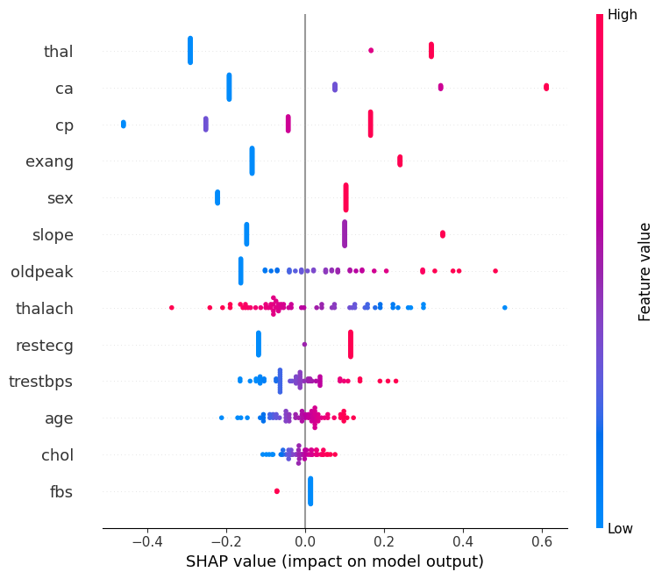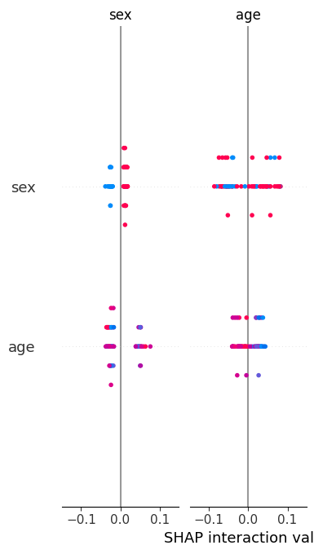
Figure 8: SHAP Summary Plot for LR Figure 9: SHAP Summary Plot RF
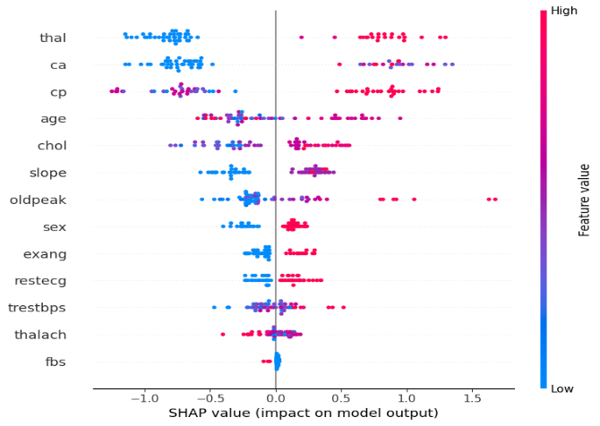
Figure 10: SHAP Summary Plot XGBoost

6. RESULTS
6.1 Comprehensive Model Performance Comparison
All three models were evaluated at three stages: (1) No SMOTE — trained on the raw imbalanced training set with default hyperparameters; (2) SMOTE before tuning — trained on SMOTE-balanced data with default hyperparameters; (3) SMOTE + Tuned — trained on SMOTE-balanced data with GridSearchCV-optimised hyperparameters.
Model | Stage | Accuracy | Precision | Recall | F1-Score | ROC-AUC
Logistic Regression | No SMOTE | 0.8333 | 0.8462 | 0.7857 | 0.8148 | 0.9487
Logistic Regression | SMOTE (Before Tuning) | 0.8333 | 0.8462 | 0.7857 | 0.8148 | 0.9464
Logistic Regression | SMOTE + Tuned | 0.8500 | 0.8519 | 0.8214 | 0.8364 | 0.9464
Random Forest | No SMOTE | 0.8667 | 0.8846 | 0.8214 | 0.8519 | 0.9453
Random Forest | SMOTE (Before Tuning) | 0.8333 | 0.8750 | 0.7500 | 0.8077 | 0.9275
Random Forest | SMOTE + Tuned | 0.8000 | 0.8333 | 0.7143 | 0.7692 | 0.9509
XGBoost | No SMOTE | 0.8667 | 0.8846 | 0.8214 | 0.8519 | 0.8917
XGBoost | SMOTE (Before Tuning) | 0.8667 | 0.8846 | 0.8214 | 0.8519 | 0.9051
XGBoost | SMOTE + Tuned | 0.8667 | 0.8846 | 0.8214 | 0.8519 | 0.9196
Table 3: Comprehensive model comparison across all three stages
Table 3 summarises the performance of Logistic Regression, Random Forest, and XGBoost before and after applying SMOTE and hyperparameter tuning.
Logistic Regression showed a slight improvement after tuning, with accuracy increasing from 83.33% to 85.00% and recall improving from 78.57% to 82.14%. Random Forest achieved strong baseline performance but experienced a decrease in accuracy after SMOTE and tuning, although it produced the highest ROC-AUC score of 0.9509.
XGBoost demonstrated the most consistent performance across all stages, maintaining an accuracy of 86.67%, precision of 88.46%, recall of 82.14%, and F1-score of 0.8519. Its ROC-AUC also improved after tuning from 0.8917 to 0.9196.
Overall, XGBoost provided the best balance between accuracy, precision, recall, and F1-score, while Random Forest achieved the highest ROC-AUC value. These results indicate that ensemble learning methods are effective for heart disease prediction, with XGBoost emerging as the most reliable model for this dataset.
6.2 ROC Curve Analysis
The ROC curves demonstrated that all three tuned models were effective at distinguishing between patients with and without heart disease. Random Forest achieved the highest ROC-AUC score (0.951), closely followed by Logistic Regression (0.946), while XGBoost achieved a ROC-AUC of 0.920. Since all values exceeded 0.90, the models can be considered strong classifiers. The results indicate that each model possesses a high level of discriminative ability, with Random Forest showing a slight advantage in separating the two classes.
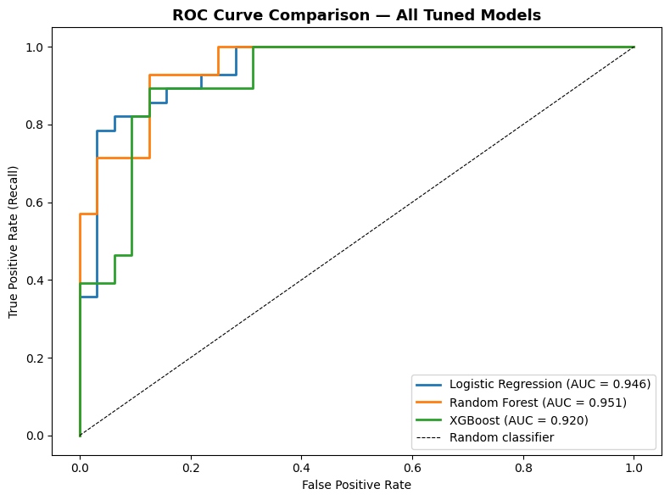
Figure 11: ROC Curve Comparison of Tuned Logistic Regression, Random Forest, and XGBoost Models.

6.3 Confusion Matrix Analysis
Figure 12 presents the confusion matrices for the tuned Logistic Regression, Random Forest, and XGBoost models. Logistic Regression correctly classified 28 non-disease cases and 23 disease cases, with 4 false positives and 5 false negatives. XGBoost achieved similar performance, correctly identifying 29 non-disease cases and 23 disease cases while producing only 3 false positives and 5 false negatives.
Random Forest correctly classified 28 non-disease cases and 20 disease cases but generated 8 false negatives, indicating that more patients with heart disease were incorrectly classified as healthy. In healthcare applications, false negatives are particularly important because they may lead to missed diagnoses and delayed treatment.
Overall, XGBoost produced the most favourable confusion matrix by maintaining a high number of correct classifications while generating the fewest false positives. This result supports its strong overall performance and suitability for heart disease prediction.
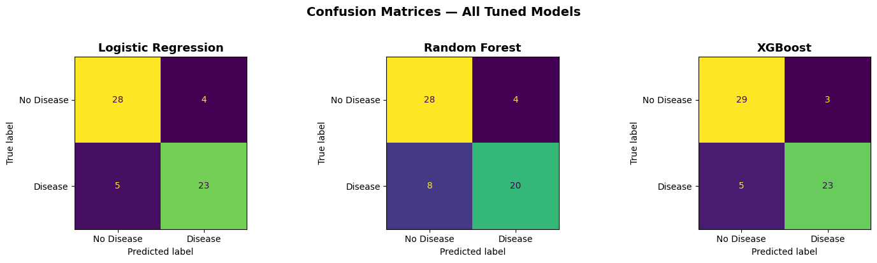
Figure 12: Confusion Matrices
6.4 SHAP Explainability Results
SHAP analysis was applied to the tuned Logistic Regression, Random Forest, and XGBoost models to identify the features that contributed most to heart disease predictions. The SHAP feature importance plots showed that thal, ca, cp, exang, and oldpeak were among the most influential predictors across the models; while fasting blood sugar (fbs) had the lowest impact.
The SHAP summary plots further revealed how feature values influenced predictions. Higher values of thal, ca, oldpeak, and exang generally increased the likelihood of heart disease, whereas higher values of thalach were associated with a lower predicted risk. This finding is consistent with the correlation analysis and established clinical knowledge.
Overall, the three models showed strong agreement regarding the most important predictors, particularly thal, ca, cp, oldpeak, and thalach. This consistency increases confidence in the reliability of the identified clinical risk factors and demonstrates that the models are learning meaningful patterns from the data rather than relying on model-specific behaviour.
6.5 Key Findings
- The three-stage comparison (No SMOTE, SMOTE before tuning, and SMOTE + tuned) enabled the impact of class balancing and hyperparameter optimisation on model performance to be evaluated.
- Logistic Regression showed improved performance after tuning, achieving an accuracy of 85.00% and a ROC-AUC of 0.9464.
- Random Forest achieved the highest ROC-AUC score (0.9509), demonstrating strong discrimination between patients with and without heart disease.
- XGBoost provided the most consistent overall performance, maintaining an accuracy of 86.67%, precision of 88.46%, recall of 82.14%, and F1-score of 0.8519 after tuning.
- SHAP analysis consistently identified thal, ca, cp, oldpeak, and thalach as the most influential predictors of heart disease across the models.
- The strong agreement between the models on the most important features increases confidence in the reliability of the identified clinical risk factors and demonstrates the robustness of the explainability results.

7. ANALYSIS AND DISCUSSION
7.1 Interpretation of Results
The results demonstrate that machine learning models can effectively predict heart disease using clinical features from the Cleveland dataset, with all three models exceeding a ROC-AUC of 0.90 after optimisation. XGBoost achieved the best overall balance of accuracy, precision, recall and F1-score, Random Forest the highest ROC-AUC, and Logistic Regression remained competitive despite its simpler linear structure — suggesting the dataset contains a mix of linear and non-linear relationships that all three architectures were able to exploit.
7.2 Effect of SMOTE
SMOTE was applied to the training data to address class imbalance, generating synthetic minority-class samples so that the 128 negative and 109 positive training cases became balanced at 128 each. This improved class representation during training, reducing bias towards the majority class and supporting more balanced identification of disease-positive patients.
7.3 Model Comparison
Logistic Regression remained a highly interpretable baseline despite its linear structure, while Random Forest's higher ROC-AUC came at the cost of lower recall than XGBoost — a less favourable trade-off in a clinical context where missed positive cases carry the greater risk. XGBoost offered the best overall balance between identifying positive cases and minimising false predictions, consistent with its design of focusing successive trees on the hardest-to-classify samples.
7.4 Clinical Relevance
The identified predictors are consistent with established cardiovascular risk factors: chest pain type, maximum heart rate, ST depression, number of major vessels and thalassemia all have well-documented associations with heart disease. Recall is particularly important clinically, since false negatives mean disease-positive patients being misclassified as healthy, so models that maintain high recall alongside overall accuracy are preferable for healthcare applications.
7.5 Explainability Discussion
The strong cross-model agreement on thal, ca, cp, oldpeak and thalach as key predictors, consistent with the correlation analysis and EDA, suggests the models learned clinically meaningful patterns rather than relying on model-specific or random behaviour — supporting the potential of this combination of predictive performance and explainability as a healthcare decision-support tool.

7.6 Limitations
Despite achieving strong predictive performance, this study has several limitations. First, the dataset was relatively small, containing only 303 patient records, which may limit the generalisability of the findings to broader and more diverse populations. Second, SMOTE generates synthetic minority-class samples, which may not fully represent real clinical cases and could introduce artificial patterns into the training data. Finally, the dataset is cross-sectional in nature and therefore cannot be used to establish causal relationships between risk factors and heart disease outcomes.

8. CONCLUSION
This study presented a comparative framework for heart disease risk prediction using three machine learning models: Logistic Regression, Random Forest, and XGBoost. The methodology incorporated SMOTE for class balancing, GridSearchCV with five-fold cross-validation for hyperparameter optimisation, and SHAP for model explainability.
A three-stage evaluation framework (No SMOTE, SMOTE before tuning, and SMOTE + tuned) was used to assess the impact of class balancing and hyperparameter optimisation on model performance. Logistic Regression achieved strong predictive performance with a ROC-AUC of 0.9464, while Random Forest achieved the highest ROC-AUC score of 0.9509. XGBoost demonstrated the most consistent overall performance, maintaining high accuracy (86.67%), precision (88.46%), recall (82.14%), and F1-score (85.19%) after tuning.
SHAP analysis identified thal, ca, cp, oldpeak, and thalach as the most influential predictors of heart disease across the models. The consistency of these findings across different model architectures increases confidence in their clinical relevance and supports established cardiovascular knowledge.
Overall, the results demonstrate that machine learning models can effectively predict heart disease risk using routinely collected clinical data. The combination of predictive performance and explainability highlights the potential of these models as decision-support tools for healthcare applications.

9. FUTURE WORK
- Validate the proposed models on larger, multi-centre datasets such as MIMIC-III and UK Biobank to improve generalisability across diverse patient populations.
- Explore deep learning approaches with built-in attention mechanisms and explainability, such as TabNet, and compare their performance with traditional machine learning models.
- Investigate LIME alongside SHAP to provide additional local explanations and assess the consistency of feature importance across explainability techniques.
- Evaluate model fairness and bias across demographic groups, such as age and sex, to ensure equitable performance in clinical applications.
- Apply repeated stratified k-fold cross-validation to obtain more robust performance estimates and reduce the impact of a single train-test split.
- Develop ensemble or stacking approaches that combine Logistic Regression, Random Forest, and XGBoost to determine whether predictive performance can be further improved.
- Deploy the final model as a clinical decision-support web application using frameworks such as Streamlit or Flask, incorporating real-time predictions and patient-level SHAP explanations for healthcare professionals.

REFERENCES
[1] Breiman, L. (2001) 'Random Forests', Machine Learning, 45(1), pp. 5–32. Available at: https://doi.org/10.1023/A:1010933404324
[2] Chen, T. and Guestrin, C. (2016) 'XGBoost: A scalable tree boosting system', Proceedings of the 22nd ACM SIGKDD International Conference on Knowledge Discovery and Data Mining, San Francisco, CA, 13–17 August 2016, pp. 785–794. Available at: https://doi.org/10.1145/2939672.2939785
[3] Janosi, A., Steinbrunn, W., Pfisterer, M. and Detrano, R. (1989) Heart Disease [Dataset]. UCI Machine Learning Repository. Available at: https://doi.org/10.24432/C52P4X
[4] Lundberg, S.M. and Lee, S.I. (2017) ‘A unified approach to interpreting model predictions’, Advances in Neural Information Processing Systems (NeurIPS), Long Beach, CA, 4–9 December 2017, vol. 30, pp. 4765–4774. Available at: https://proceedings.neurips.cc/paper/7062-a-unified-approach-to-interpreting-model-predictions
[5] Lundberg, S.M., Erion, G., Chen, H., DeGrave, A., Prutkin, J.M., Nair, B. and Lee, S.I. (2020) 'From local explanations to global understanding with explainable AI for trees', Nature Machine Intelligence, 2(1), pp. 56–67. Available at: https://doi.org/10.1038/s42256-019-0138-9
[6] Nahar, N. et al. (2026) 'Stacked ensemble model with explainable AI for early detection of heart disease', Analytical Science Advances. Available at: https://doi.org/10.1002/ansa.70072
[7] Banerjee, T. and Paçal, İ. (2025) ‘A systematic review of machine learning in heart disease prediction’, Turkish Journal of Biology, 49(5), pp. 600–634. Available at: https://doi.org/10.55730/1300-0152.2766
[8] Soni, J., Ansari, U., Sharma, D. and Soni, S. (2011) 'Predictive data mining for medical diagnosis: An overview of heart disease prediction', International Journal of Computer Applications, 17(8), pp. 43–48.Available at: https://www.ijcaonline.org/volume17/number8/pxc3872860.pdf
[9] Raman, S., Thakkar, D., Calixte, J., Kumar, R., Sporn, K., Marla, K., Goel, D., Gopali, R., Chetla, N., Pasha, S., Ravisankar, N., Lee, R. and Ionita, C. (2026) ‘Machine learning for coronary heart disease prediction: Comparative analysis of Framingham and Cleveland subset of the UCI dataset with SHAP-based interpretability’, Epidemiologia, 7(3), 75. Available at: https://doi.org/10.3390/epidemiologia7030075
[10] Yang, J. and Guan, X. (2022) 'A heart disease prediction model based on feature optimisation and SMOTE-XGBoost algorithm', Information, 13(10), p. 475. Available at: https://doi.org/10.3390/info13100475
APPENDIX
Code link: https://colab.research.google.com/github/kakarlarenusree/renu_project_Heart-Disease-Risk-Prediction/blob/main/heartdisease_final_d.ipynb
Figure A: shows the class distribution of the training data before and after the application of SMOTE. The technique generated synthetic minority-class observations to balance the dataset, reducing the impact of class imbalance during model training while maintaining a realistic test set for evaluation.
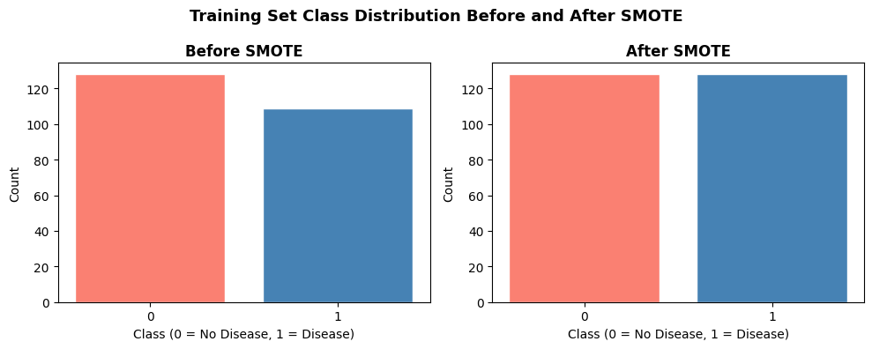
Fig A: Before Smote / After Smote
Effect of SMOTE and Hyperparameter Tuning
Figure B illustrates the impact of SMOTE and hyperparameter tuning on ROC-AUC and recall across the three machine learning models. The ROC-AUC scores remained consistently high across all stages, indicating strong classification performance regardless of preprocessing and optimisation techniques.
For Logistic Regression, hyperparameter tuning resulted in a slight improvement in recall while maintaining a high ROC-AUC score. Random Forest achieved the highest ROC-AUC after tuning; however, recall decreased compared with the baseline model. XGBoost maintained stable performance across all stages, with only minor changes in ROC-AUC and recall.
Overall, the results suggest that SMOTE and hyperparameter tuning influenced model behaviour differently depending on the algorithm. While the improvements were modest due to the relatively balanced dataset, these techniques contributed to more robust model development and enabled a fair comparison between models.
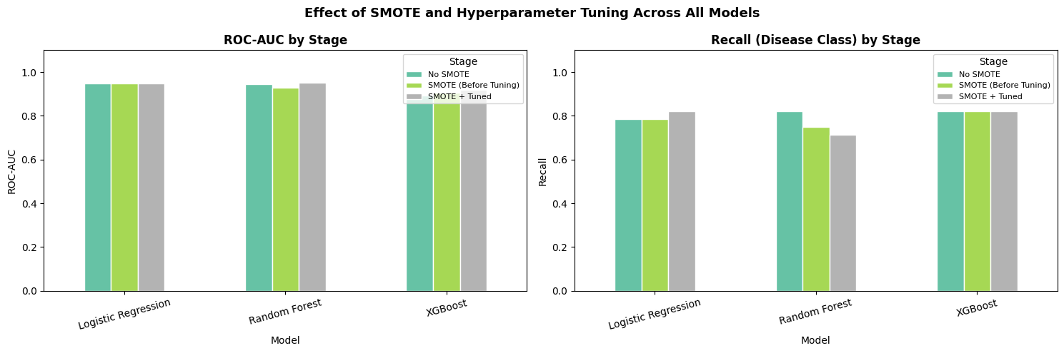
Figure B. Effect of SMOTE and Hyperparameter Tuning on ROC-AUC and Recall Across Logistic Regression, Random Forest, and XGBoost.

Comparative SHAP Analysis
Figure C compares the mean absolute SHAP values across Logistic Regression, Random Forest, and XGBoost. The results show strong agreement between the models regarding the most influential predictors of heart disease.
Across all three models, thal, ca, and cp consistently ranked among the most important features. XGBoost assigned the highest importance to these variables, while Logistic Regression and Random Forest identified similar patterns with lower SHAP magnitudes. Features such as oldpeak, slope, and exang also demonstrated notable contributions to model predictions. In contrast, fasting blood sugar (fbs) had the lowest importance across all models.
The consistency of feature rankings across different model architectures suggests that the identified predictors are robust and clinically meaningful. This agreement increases confidence in the reliability of the explainability results and supports the use of these features for heart disease risk prediction.
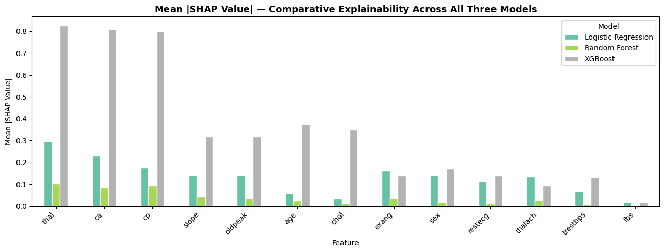
Figure C. Comparison of Mean Absolute SHAP Values Across Logistic Regression, Random Forest, and XGBoost Models.

